WEEK 1 TASK
Data Acquisition, Cleaning, and Exploratory Analysis

Titanic Passenger Dataset

Tools: Python • Pandas • NumPy • Matplotlib • Seaborn • Jupyter Notebook

Student Name: Sharanya A
Internship: Data Science Internship
Week: 1

1. Introduction
This Week 1 project demonstrates the fundamental data science workflow of acquiring a public dataset, inspecting its structure, cleaning data-quality issues, performing preprocessing, and conducting exploratory data analysis (EDA) using Python. The Titanic passenger dataset was selected because it contains a mixture of numerical and categorical variables and includes realistic data-quality issues such as missing observations and duplicate rows. The analysis focuses on passenger survival and explores how survival varies across gender and passenger class, while also examining age, fare, and relationships among numerical variables.
The work was completed in Jupyter Notebook using Pandas and NumPy for data handling and Matplotlib and Seaborn for visualization. The final cleaned dataset contains 780 observations and 14 variables after duplicate removal and preprocessing. Multiple visualizations were created to communicate data-quality issues, distributions, group differences, and correlations. The findings provide a foundation for more advanced statistical analysis and machine-learning work in later internship tasks.

2. Project Objective
- Acquire and load a publicly available dataset using Python.
- Inspect the dataset structure, variables, data types, and data quality.
- Identify and handle missing values using appropriate techniques.
- Identify and remove duplicate observations.
- Correct data types where categorical variables are better represented as categories.
- Perform descriptive and exploratory analysis.
- Create visualizations that highlight important trends and relationships.
- Summarize the main insights and identify areas for future analysis.

3. Dataset Description
The Titanic dataset contains passenger-level information from the Titanic voyage. The selected Seaborn version contains variables describing survival status, passenger class, gender, age, family relationships, fare, embarkation information, and several derived categorical indicators.
Variable | Description | Type
survived | Survival status: 0 = did not survive, 1 = survived | Integer
pclass | Passenger class: 1, 2, or 3 | Categorical
sex | Passenger sex | Categorical
age | Passenger age in years | Numeric
sibsp | Number of siblings/spouses aboard | Numeric
parch | Number of parents/children aboard | Numeric
fare | Passenger ticket fare | Numeric
embarked | Port code of embarkation | Categorical
class | Text representation of passenger class | Categorical
who | Broad passenger category | Categorical
adult_male | Indicator for adult male passenger | Boolean
embark_town | Town/port name for embarkation | Categorical
alive | Text representation of survival | Categorical
alone | Whether passenger travelled alone | Boolean

4. Data Acquisition
The dataset was acquired through Seaborn's publicly available sample-dataset interface. The load_dataset() function retrieves the Titanic dataset and loads it directly into a Pandas DataFrame.
import pandas as pd
import numpy as np
import matplotlib.pyplot as plt
import seaborn as sns
df = sns.load_dataset("titanic")
The dataset was then saved as a CSV file for reproducibility and subsequent processing.
df.to_csv("titanic.csv", index=False)

5. Tools and Technologies
- Python – primary programming language.
- Jupyter Notebook – interactive development and documentation environment.
- Pandas – data loading, inspection, cleaning, grouping, and aggregation.
- NumPy – numerical operations and data-type support.
- Matplotlib – plotting and figure customization.
- Seaborn – statistical visualizations and exploratory graphics.

6. Initial Data Inspection
Initial inspection was performed before cleaning to understand the dimensions, columns, data types, and completeness of the dataset.
df.head()
df.shape
df.columns
df.dtypes
df.info()
The pre-cleaning analysis contained 784 rows. The inspection revealed missing values in variables such as age, deck, and embark_town, and four duplicate rows were identified. These findings motivated the subsequent cleaning steps.

7. Data Cleaning and Preprocessing

7.1 Missing-Value Assessment
Missing values were first quantified using Pandas. A missing-value heatmap was also created to visually inspect where incomplete observations occurred.
df.isnull().sum()
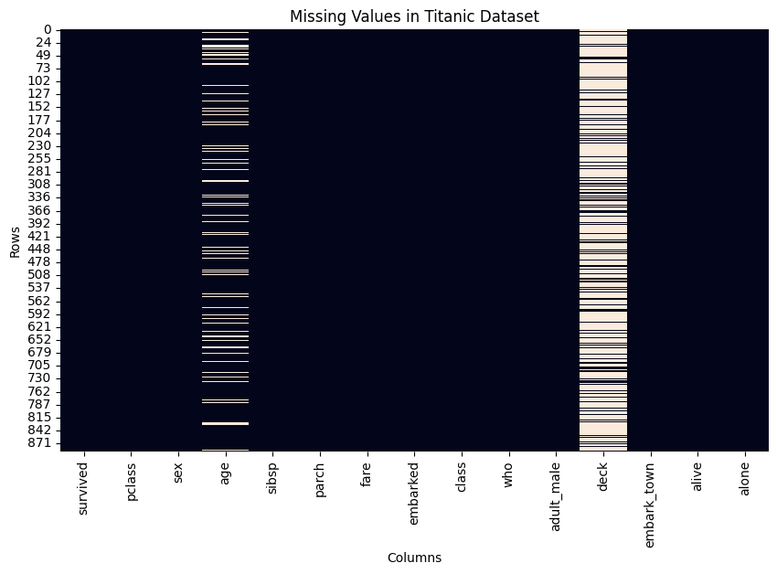
Figure 1. Missing Values in the Titanic Dataset Before Cleaning.

7.2 Handling Missing Age Values
Missing age values were replaced with the median age. The median was selected because it is less sensitive to extreme observations than the mean and is therefore a robust choice for a variable such as age.
df["age"] = df["age"].fillna(df["age"].median())

7.3 Handling Missing Categorical Values
The missing values in the embarkation variables were handled using the most frequent category (mode). Mode imputation is appropriate for a categorical variable because it preserves a valid category rather than introducing a numerical estimate.
df["embarked"] = df["embarked"].fillna(df["embarked"].mode()[0])
df["embark_town"] = df["embark_town"].fillna(df["embark_town"].mode()[0])

7.4 Handling the Deck Variable
The deck variable contained a very large amount of missing information. Because the variable was not required for the planned Week 1 analysis and retaining it would add substantial incompleteness, it was removed from the working dataset.
df = df.drop(columns=["deck"])

7.5 Duplicate Records
Four duplicate rows were identified. Duplicate observations can distort descriptive statistics and visualizations, so they were removed.
df.duplicated().sum()
df = df.drop_duplicates()
df.duplicated().sum()
After removal, the duplicate count was 0 and the cleaned dataset contained 780 rows.

7.6 Data-Type Correction
Variables representing categories were converted to the Pandas category data type. Passenger class was also treated as categorical because values 1, 2, and 3 represent distinct passenger classes rather than a continuous numeric measurement.
df["sex"] = df["sex"].astype("category")
df["embarked"] = df["embarked"].astype("category")
df["pclass"] = df["pclass"].astype("category")

7.7 Final Cleaned Dataset
After cleaning, the final working dataset contained 780 rows and 14 columns. Duplicate rows were removed and the remaining missing values relevant to the analysis were handled. The cleaned dataset was saved for reuse.
df.to_csv("titanic_cleaned.csv", index=False)

8. Exploratory Data Analysis

8.1 Descriptive Statistics
Descriptive statistics were generated to understand the central tendency, spread, and range of numerical variables such as age and fare.
df.describe()
Metric | Age | Fare
Count | 780 | 780
Mean | 29.65 | 34.71
Std. deviation | 13.73 | 52.16
Minimum | 0.42 | 0.00
Median | 28.25 | 15.90
Maximum | 80.00 | 512.33

8.2 Overall Survival Distribution
The survival variable was examined using value counts and an overall survival-rate calculation. The overall survival rate was approximately 41.2% before final duplicate removal and remained broadly similar after cleaning.
df["survived"].value_counts()
survival_rate = df["survived"].mean() * 100
print(f"Overall survival rate: {survival_rate:.2f}%")
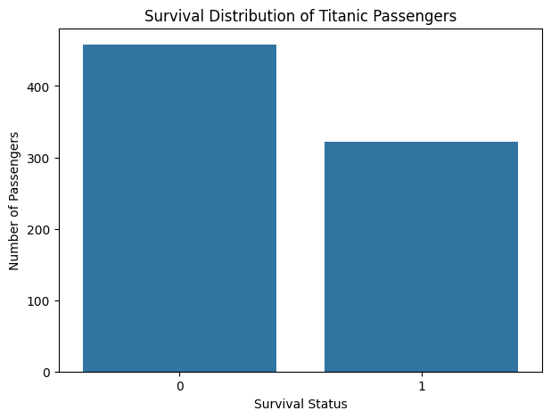
Figure 2. Survival Distribution of Titanic Passengers.

8.3 Survival Rate by Gender
Survival rates were calculated separately for male and female passengers. The analysis showed a substantial difference between the groups: the observed rates were approximately 74.0% for females and 21.7% for males.
gender_survival = df.groupby("sex", observed=True)["survived"].mean() * 100
print(gender_survival)
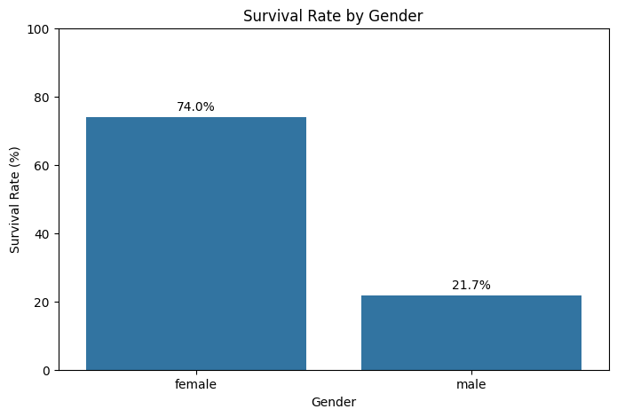
Figure 3. Survival Rate by Gender.

8.4 Survival Rate by Passenger Class
Passenger class was compared using group-wise survival rates. The observed rates were approximately 63.7% for first class, 50.6% for second class, and 25.7% for third class.
class_survival = df.groupby("pclass", observed=True)["survived"].mean() * 100
print(class_survival)
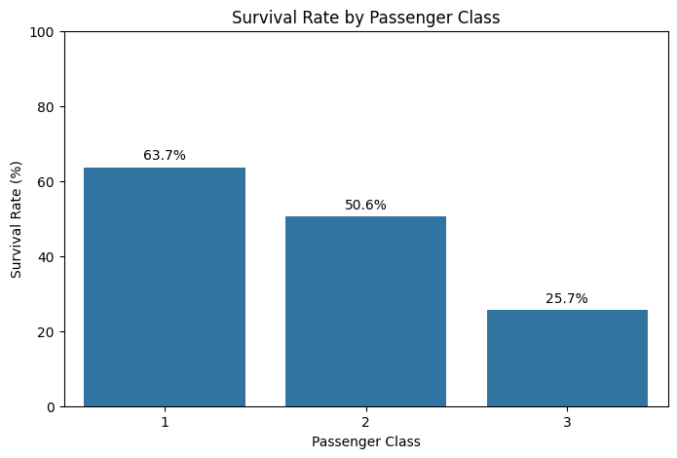
Figure 4. Survival Rate by Passenger Class.

8.5 Age Distribution
The age distribution shows a broad range of passenger ages from approximately 0.42 to 80 years. The mean age was about 29.65 years and the median was 28.25 years. The distribution is concentrated around the young-adult and adult age ranges, with fewer observations at the oldest ages.
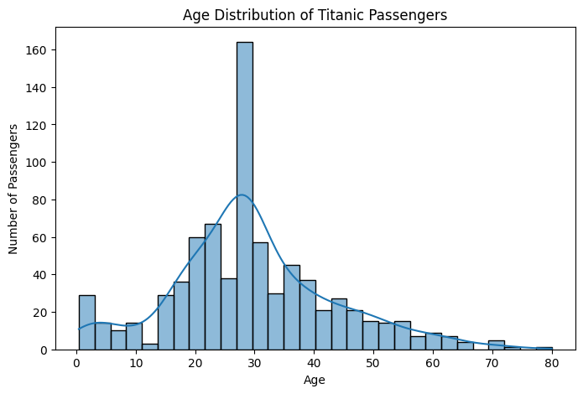
Figure 5. Age Distribution of Titanic Passengers.

8.6 Fare Distribution and Potential Outliers
Fare values were strongly right-skewed. The median fare was 15.90, while the mean was 34.71 and the maximum was 512.33. The difference between the mean and median indicates that a smaller number of high-fare observations increased the average. Such observations were retained because a high fare can represent a genuine passenger or ticket characteristic rather than a data-entry error.
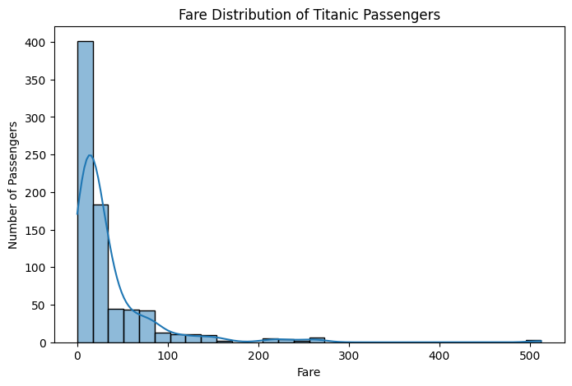
Figure 6. Fare Distribution of Titanic Passengers.

8.7 Correlation Analysis
A correlation matrix was generated for numerical variables. Survival had a positive correlation of approximately 0.25 with fare, while its correlation with age was approximately -0.08. Sibling/spouse count and parent/child count showed a correlation of approximately 0.38. These values indicate associations, not causal relationships.
numeric_df = df.select_dtypes(include=np.number)
correlation = numeric_df.corr()
sns.heatmap(correlation, annot=True, cmap="coolwarm", fmt=".2f")
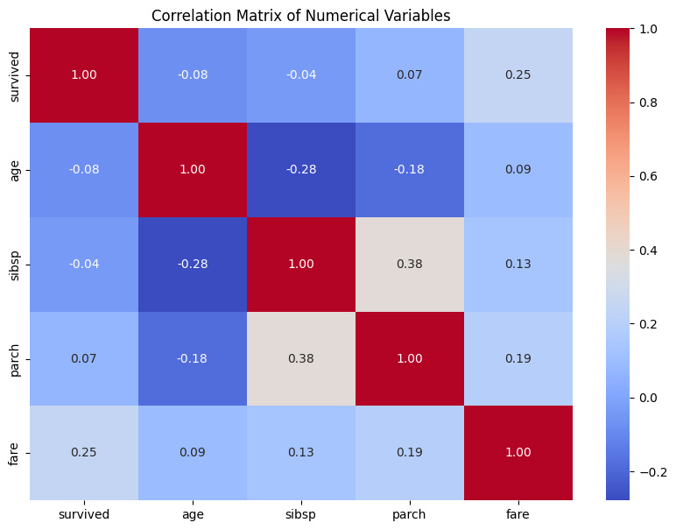
Figure 7. Correlation Matrix of Numerical Variables.

9. Key Insights
- Overall, fewer passengers survived than did not survive, with the observed survival proportion around 41%.
- Gender showed a strong difference in observed survival rates: approximately 74% of female passengers survived compared with about 22% of male passengers.
- Passenger class was associated with survival. First-class passengers had the highest observed survival rate, followed by second-class passengers, while third-class passengers had the lowest.
- Passenger ages covered a wide range, from infants to passengers around 80 years old, with most observations concentrated in the young-adult and adult ranges.
- Fare was strongly right-skewed, with most passengers paying comparatively lower fares and a smaller number paying much higher fares.
- The correlation analysis suggests that fare has a modest positive association with survival, while age has only a weak negative linear association with survival in this dataset.
- The results identify gender and passenger class as particularly useful variables for deeper statistical testing and predictive modeling in later stages.

10. Cleaning Decisions and Rationale
Issue | Action | Rationale
Missing age | Median imputation | Robust to extreme ages and preserves observations.
Missing embarked / embark_town | Mode imputation | Appropriate for categorical variables.
High missingness in deck | Column removed | Not needed for Week 1 analysis and contained substantial missing information.
4 duplicate rows | Removed | Prevents duplicate observations from affecting analysis.
sex, embarked, pclass | Converted to category | Better represents categorical variables and improves data semantics.

11. Limitations
- The Titanic dataset represents a historical event and should not be generalized automatically to modern populations or other transportation contexts.
- Some variables contain missing information, requiring assumptions during preprocessing.
- Removing the deck variable means any information potentially contained in deck location was not used in this analysis.
- The EDA identifies associations and patterns but does not establish causal relationships.
- The analysis is descriptive; statistical hypothesis testing and predictive modeling would be needed to validate relationships and assess predictive performance.

12. Potential Areas for Further Analysis
- Perform hypothesis tests to determine whether survival differences by gender or class are statistically significant.
- Investigate interactions between gender and passenger class.
- Engineer additional features such as family size and child/adult groups.
- Build classification models to predict survival and compare model performance.
- Use cross-validation and additional evaluation metrics to assess predictive reliability.

13. Conclusion
This Week 1 project completed the essential data preparation and exploratory analysis workflow using the Titanic passenger dataset. The dataset was acquired and inspected with Python, missing values and duplicate records were identified, appropriate cleaning decisions were applied, and categorical variables were assigned suitable data types. The final working dataset contained 780 observations and 14 variables.
EDA revealed several meaningful patterns. Female passengers had a substantially higher observed survival rate than male passengers, and higher passenger classes generally had higher survival rates. Age showed a broad distribution, while fare was strongly right-skewed with a small number of high-value observations. Correlation analysis provided additional information about linear relationships among numerical variables. Overall, the project demonstrates how systematic data cleaning and visualization can transform raw data into interpretable insights and provides a strong foundation for statistical analysis and machine learning in later weeks.

14. References
1. Seaborn documentation and publicly available example datasets – Titanic dataset accessed through Seaborn's load_dataset() interface.
2. Pandas documentation – DataFrame operations, missing-value handling, grouping, and data-type conversion.
3. Matplotlib and Seaborn documentation – plotting and statistical visualization techniques.

